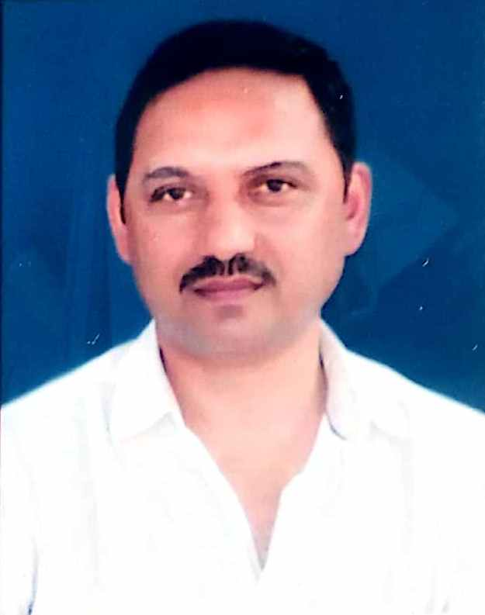
CURRICULUM-VITAE
Prof. Digar Singh Farswan
Professor & Head of School, School of Education
Uttarakhand Open University Haldwani Nainital
Email- dsfarswan@uou.ac.in Mob- 9897262526

CAREER OBJECTIVES:
- To build a career with high growth prospects by integrating all my capabilities and exploiting opportunities offered.
ACADEMIC QUALIFICATIONS:
- High School from U.P. Board Allahabad in 1990 with Second Division.
- Intermediate From U.P. Board Allahabad in 1992 with Second Division.
- Graduation From Kumaun University, Nainital in 1995 with Second Division.
- Graduation From Uttarakhand Open University Haldwani in 2019 with First Division.
- P.G. (Economics) From Kumaun University, Nainital in 1997 with Second Division.
- P.G. (English) From Vinayaka Mission University, Salem in 2013 with First Division.
- P.G. History from Uttarakhand Open University Haldwani in 2015 with First Division.
- P.G. Education from Uttarakhand Open University Haldwani in 2022 with First Division
PROFESSIONAL QUALIFICATIONS:
- B.Ed. From Kumaun University, Nainital in 2000 with First Division.
- M.Ed. From Kumaun University, Nainital in 2003 with Second Division.
- M. Phil Education from Vinayaka Mission University, Salem in 2008 with First Division.
- Ph. D Education from Kumaun University, Nainital in 2012.
RESEARCH PAPERS & ARTICLES:
Published 48 Research Paper/ Articles in International and National Peer Reviewed and UGC Care Journals
CHAPTER IN BOOKS:
10 Chapter Published in various books with ISBN.
BOOKS:
02 Book Published with ISBN.
REFRESHER COURSE/ INDUCTIONPROGRAMME/ FDP:
1. Refresher Course in Education Organized by UGC ASC Kumaun University Nainital with Grade “A” 2008.
2. One Month “Faculty Induction Programme- F.I.P. 01” Organized by Uttarakhand Open University Haldwani, Nainital, 05 March 2021 to 05 April 2021 with Grade “A”.
3. UGC Approved Short-Term Professional Development Programme on “Implementation of NEP – 2020 for University and College Teachers” Organized by STRIDE IGNOU New Delhi Held on 27 October to 05 November 2022 and Obtained Grade A
4. UGC Approved Short-Term Professional Development Programme on “Design and Development of Self-Learning Material for Distance, Online and Blended Learning” Organized by STRIDE IGNOU New Delhi Held on 13-18 March 2023 and Obtained Grade A+
5. Successfully Completed Professional Development Programme 2- Credit SWAYAM Course on “National Education Policy-2020” Organized by STRIDE IGNOU New Delhi Held on 1-31 January 2024 and Obtained Grade A
SEMINARS & CONFERENCES:
Presented 30 papers in International and National Seminar/Conferences as a Resource person/Keynote speaker/Chairman
RESEARCH EXPERIENCE:
1. Supervised Ph.D. Scholar Neeraj Kandpal Enrolment No- 13041017 of Education of Uttarakhand Open University, Haldwani. (Nainital) 2024.
2. Supervised 08 MAJMC and M. Ed. dissertation of Journalism and Media Studies, Uttarakhand Open University, Haldwani. (Nainital) 2023.
EXPERIENCE:
- 19 years of experience in Education and Teacher Education.
PERSONAL DETAIL:
Father’s Name : Shri Jagat Singh
Mother’s Name : Smt. Jashoda Devi
Date of Birth : 12 April 1973
Nationality : Indian
Religion : Hindu
Marital Status : Married
PERMANENT ADDRESS:
Village- Dhunamani (Manitundi) Post- Dhunamani
Tahsil- Munsyari Dist- Pithoragarh Uttarakhand Pin- 262554

RESIDENTIAL ADDRESS:
Gali No-5 Jay Vihar, Lohariyasal Malla, Uchapul, Haldwani, Dist- Nainital 263139

DECLARATION:
I hereby declare that the information given above is true to the best of my knowledge and belief.
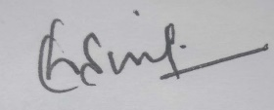

Date: 18-07-2024 (Prof. Digar Singh Farswan)
Place: Haldwani

