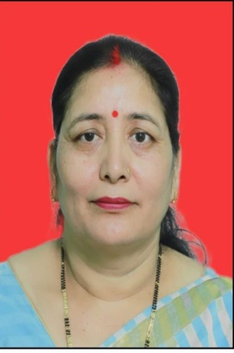 **CV**

Name- Dr. Anjana Devi

Father's Name- Bhawan Singh Bashera

Date of Birth- 5 July 1977

Designation - Assistant Professor (AC)

Academic Qualification-

|  |  |  |  |  |  |
| --- | --- | --- | --- | --- | --- |
| Qualification | PhD | M.Ed./MA | B.Ed. | PG | UG |
| Year | 2018 | 2012 | 2008 | 2011 | 1997 |
| University | Sunrise university, Alwar | Devi Ahilya Vishwavidyalaya, Indore | Kumaon University | Kumaon University | Kumaon University |

Total Teaching Experience- 14 years

Numbers of Publications-

|  |  |  |  |
| --- | --- | --- | --- |
| Research Paper | Articles | Book Chapter | Editing of Books |
| 09 | - | 11 | 1 |

Participation in seminar and Workshops –

|  |  |
| --- | --- |
| Total Numbers of Seminars | Total Numbers of workshops |
| 06 | 07 |

 Signature